- How to add fontFamily in react
- Download a font family from browser
- Paste the file in bellow path (in this Montserrat.woff is a file name)
"./assets/fonts/Montserrat.woff
- Use @font-face inside the index.css as bellow screen shot (Highlighted in yellow)
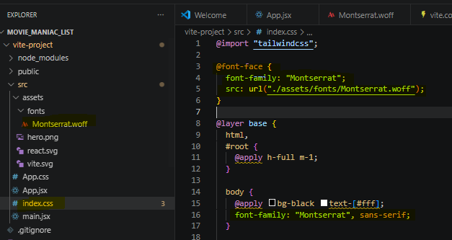

- Backdrop-blur-lg
It’s create blur effect which can be helpful to give a glossy looks
https://tailwindcss.com/docs/backdrop-filter-blur
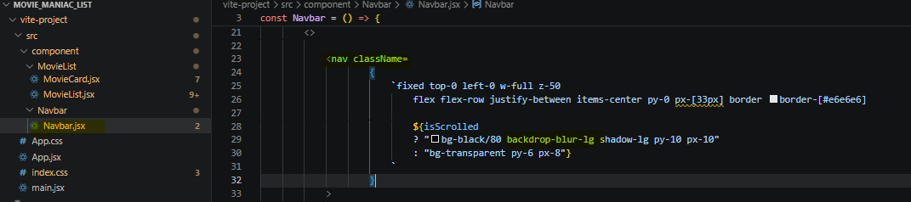
Just like bellow . 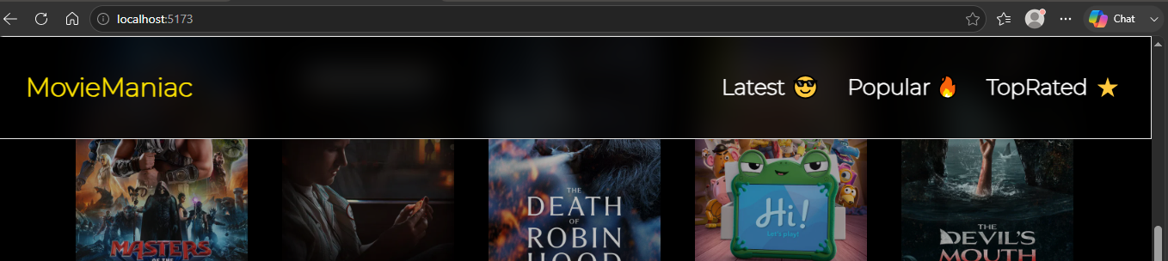
- Using “Lodsh” for sorting
- Lodash is a JavaScript library that works on the top of underscore.js. It helps in working with arrays, strings, objects, numbers, etc. It provides us with various inbuilt functions and uses a functional programming approach which that coding in JavaScript easier to understand because instead of writing repetitive functions, tasks can be accomplished with a single line of code
- To use Lodash, you must install the library via a package manager, import it into your JavaScript file using the global underscore (_)
- Intall it via
npm install lodash
- To Learn about more
https://www.geeksforgeeks.org/javascript/lodash/
- In our project we use Lodsh to use it’s orderby property. (https://www.geeksforgeeks.org/javascript/lodash-_-orderby-method/ )
- Syntax is bellow.
_.orderBy(Collection, [ iteratees ], [ orders ]);

In our Project
- Instead of writing complex sorting function we use orderby function from loadsh Libary for more understandable , easy written code in our project.

- Import lodash (MovieList.jsx)
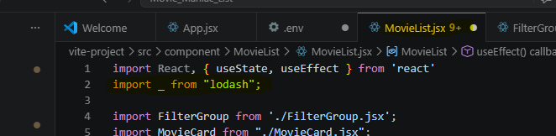

- Using _.groupBy where collection = filteredMovies, iterates=Soet.by, orders=Sort.order
